**Industrial Psychology**

**Practical 4**

**Part A**

**(To be referred by students)**

**Topic:** Create a feedback form for any infrastructural or educational facilities of your college and get at least 10 stakeholders’ responses through the form and give a basic conclusion related to the responses. The basic questions that the form could include are:

* The level of satisfaction for the facility
* Any additional Suggestions
* The most liked feature
* The least liked feature

Note: the above-mentioned questions are just examples, students can select their own set of questions if they want to.

**Name:**  
**Class:** B.Tech (CSBS)

**Semester:** VIII

**Roll no.: A016,A018,A022**

**Date of experiment:** 11/01/23

**Part B**

**(To be Done by students)**

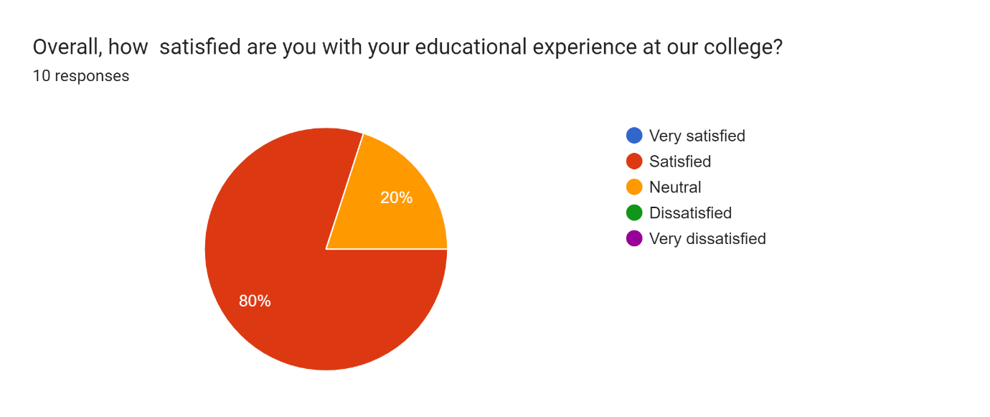

**How would you rate the following services/facilities at the college:**

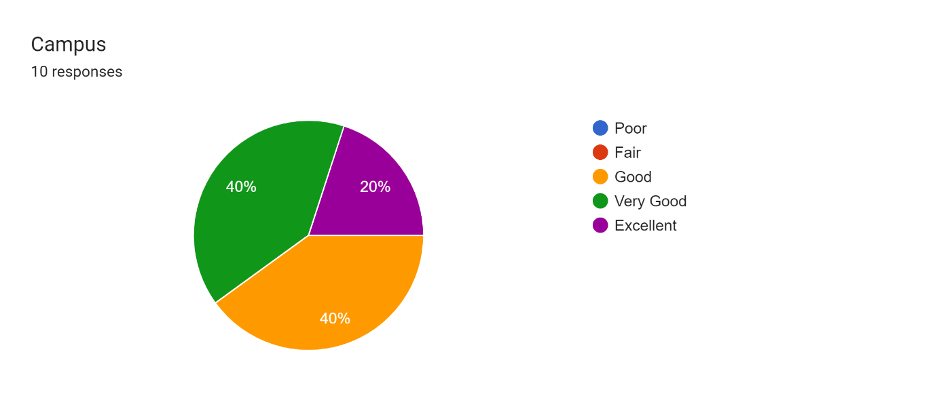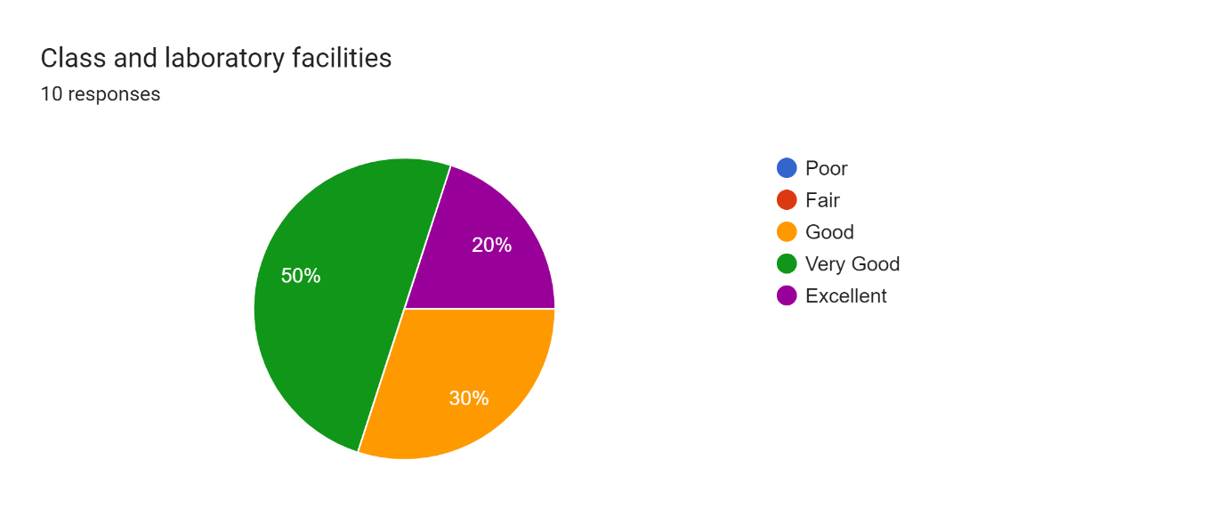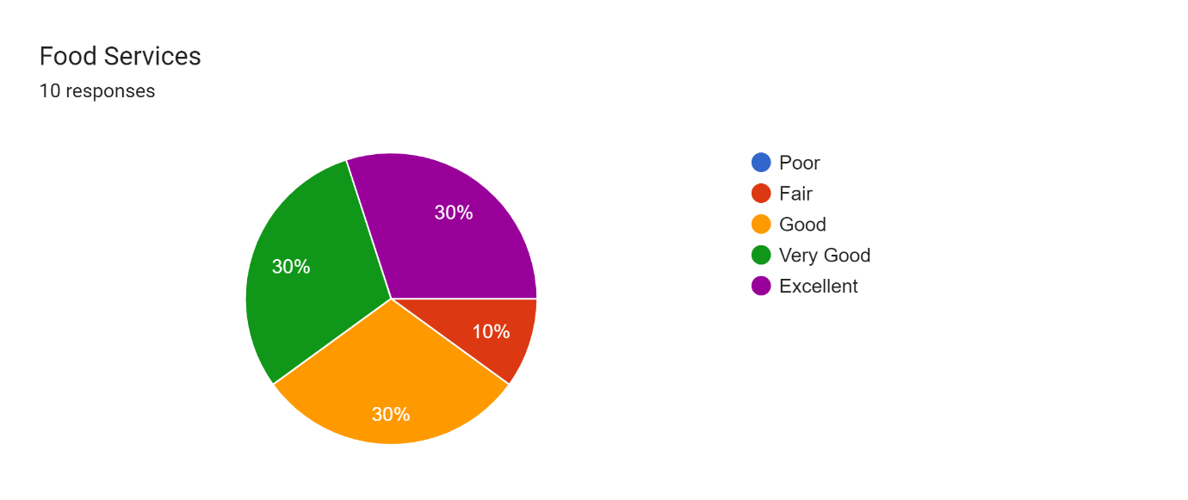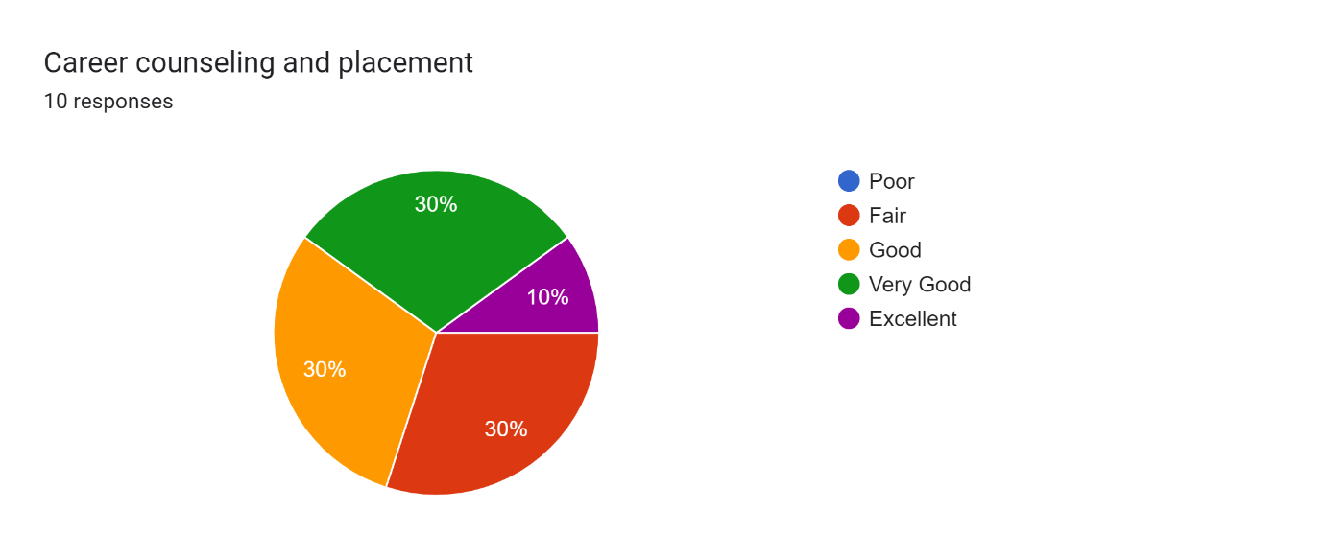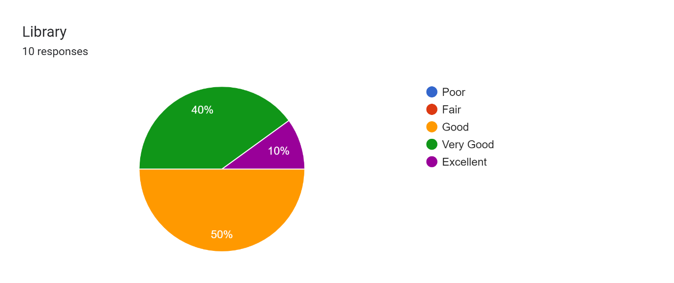Are there any other issue you are facing. If Yes, please tell what it is.

4 responses

No

Canteen Space is limited, No sports ground or sports facility

No

There is a network problem, if we use our personal network. If we use college net, many sites do not work like LinkedIn, whatsapp web, etc.

# Conclusion

We can conclude that out of 10 people:

* 8 people are satisfied are you with the educational experience at their college, while 2 are having a neutral reaction towards it
* For Campus **services/facilities:**
  + **4 people find it very good.**
  + **2 people find it excellent**
  + **4 people find it good**
* For Class and laboratory facilities
  + 2 people find it excellent
  + 5 people find it very good
  + 3 people find it good
* For Food Services
  + 3 people find it excellent
  + 3 people find it very good
  + 3 people find it good
  + 1 people find it fair
* For Career counselling and placement
  + 1 people find it excellent
  + 3 people find it very good
  + 3 people find it good
  + 3 people find it fair
* For Library
  + 1 people find it excellent
  + 4 people find it very good
  + 5 people find it good
* We also asked that Are there any other issue you are facing. And out of 10 only 2 people responded and their issues were:
  + Canteen Space is limited, No sports ground or sports facility
  + There is a network problem, if we use our personal network. If we use college net, many sites do not work like LinkedIn, whatsapp web, etc.